“Foundations for the Future” is the catch cry attached to Budget 2018 delivered by Minister of Finance Grant Robertson today - others may label it “A change of tack”.
Billed as the first steps in a plan for transformation of New Zealand’s economy, public service and indeed the way we work together as New Zealanders, there are some clear winners especially when it comes to core public services including health, education and housing.
Economic outlook
Budget 2018 paints a strong picture for the New Zealand economy with a forecast $3.7b surplus in 2018/19. Treasury forecasts show expected economic growth is expected to average about 3% over the next five years with unemployment rate expected to reach record lows at 4.1%. Inflation is expected to remain steady and stable around 2%.
Different priorities
The Labour-led Government have made no secret of the fact their priorities are different from the previous government and that is no more clearly demonstrated in their views to repaying debt and reprioritising funds which in their view will deliver on their commitment to improve the lives of all New Zealanders.
Budget 2018 is based around the Coalition Government’s key priorities, building on their 100-Day plan:
- Rebuilding critical public services
- Promoting economic development and supporting the regions
- Taking action on child poverty, housing and homelessness
- Enhancing and protecting our natural resources
- Enriching New Zealand’s culture and identity
Highlights
- Health receives $3.2 billion more in operating funding over the next four years and $850 million new capital – including $750 million to tackle some of hospitals' most urgent building problems including funding for the design work for a brand new hospital in Dunedin.
- Free doctors' visits for everyone under the age of 14 – an extra 56,000 young people from the current policy. Extension of very low-cost general practitioner (GP) visits to all Community Services Card holders and extending the Card to all Housing New Zealand tenants and New Zealanders who receive an accommodation supplement or income-related rent subsidy. This will make going to the GP cheaper by up to $30 for the 540,000 people eligible for the Card.
- Elective surgery, maternity services, air ambulances and the National Bowel Screening Programme are among the health services receiving extra funding.
- New capital funding will build schools and hundreds of new classrooms. Operating funding for education over the next four years increases by $1.6 billion to address rising demand, fund 1,500 more teachers and raise teacher-aide funding. Early childhood education gets a $590.2 million operating boost over four years, benefiting over 200,000 children. A total of $284 million goes to Learning Support to allow every child with special education needs and learning difficulties to better participate in school life.
- Housing is boosted by more than $634 million in operating funds. We will increase public housing by over 6,000 homes over the next four years, provide more transitional housing and help for the homeless and offer grants for insulation and heating.
How are the Government paying for this?
Additional Budget allowances over the next four years are in excess of $24b higher than the previous National government. This is funded by pushing out Crown debt repayments ($9b), reversing National’s tax cuts ($7.9b), higher tax collection ($5.3b) and revenue from a fairer tax system ($1.5b).
Some good news for Canterbury
Budget 2018 provides a $300m Acceleration Fund for critical projects in Canterbury following the earthquakes. This will see faster progress on the residential red zone and a multi-use arena.
An independent enquiry into the performance of the Earthquake Commission has also been launched along with new funding to establish and operate a tribunal to resolve unsettled residential insurance disputes arising from the Canterbury earthquakes.
Tax changes
Any key initiatives in relation to tax and welfare were already previously announced in December 2017 when National’s legislated tax cuts were reversed in favour of a more targeted Families Package. Once these policies are fully rolled out the poorest 384,000 families in New Zealand are expected to receive an average of an extra $3,900 per year.
Grant Robertson’s Budget 2018 speech clearly hinted that some tax changes could be on the horizon when he reaffirmed that tax collections are increasing and well ahead of budget which “gives … breathing space to properly consider any changes needed to our tax system”. With the Tax Working Group already in full train and a broad based Capital Gains Tax being the obvious elephant in the room, it is definitely a case of watch this space - over 6000 submissions have been made to date!
As has been a trend in recent budgets, the IRD will receive a further $31.3m operating spending over the next four years to crack down on tax dodgers. The bulk of this is to focus on ensuring outstanding company tax returns are filed and is expected to net $183m in additional revenue. There is a further $3m of funding earmarked to analyse the potential to improve tax compliance in specific industries via possible withholding taxes.
Recently announced proposals including the ring-fencing of rental tax losses look set to inevitably proceed in some shape or form, with this expected to boost revenue by $325m and level the playing field between investors and home buyers by stopping the ability to offset tax losses from residential properties against other. How exactly this can be achieved and whether it will be effective in dampening property speculation while encouraging investment in the productive economy, is still the topic of much debate considering the draft released for consultation recently.
The only new tax announcement contained in Budget 2018 is a direct result of the Coalition Agreement between Labour and New Zealand First whereby the Bloodstock tax rules will change so investment in a standout yearling will be tax deductible if it has been acquired by an investor with the intention of breeding for profit - whether or not they are already in a breeding business. This change is intended to encourage new investment in the breeding industry and provide economic benefit to many parts of New Zealand. These changes are expected to be in place in time for yearlings acquired at next year’s premier bloodstock sales.
While Labour has previously promised investment in research and development (R&D), this has now been quantified as $1b over four years by way of an R&D tax incentive giving eligible businesses 12.5 cents back for every dollar they spend on R&D. This funding will be available to all businesses spending more than $100k per annum on R&D. The tax incentive provided under the previous Labour government was cumbersome so the design of this new incentive currently out for public consultation will be watched with interest.
Effect on business
While Budget 2018 is set against the background of setting foundations for the future for each and every New Zealander, arguably there are limited initiatives that will directly benefit businesses in New Zealand – especially those SME’s that are the lifeblood of New Zealand’s economy. With real wages expected to grow each year with annual earnings rising to $71k by June 2022, businesses in New Zealand will need to be extremely savvy as to how they structure their operations while maintaining productivity and increasing turnover to ensure sustainable profit.
That being said, the Coalition Government has finalised the first year’s allocation of $1 billion for the Provincial Growth Fund (PGF). This will support the Government’s overall goal of productive, sustainable and inclusive growth by investing in regional economic development. It aims to create sustainable jobs, contribute to community wellbeing, lift the productivity potential of regions, and help meet New Zealand’s climate change targets.
Of the Budget 2018 funding, $245.0 million will support the Government’s One Billion Trees planting programme. A further $130.2 million of the PGF has already been committed to the regions for projects across various sectors, including forestry, tourism, energy and infrastructure including regional rail projects.
Where will my hard earned tax dollars go?
Based on a taxable income of $50,000 per year, as an illustration under Budget 2018 the tax that you pay will be spent in the following ways: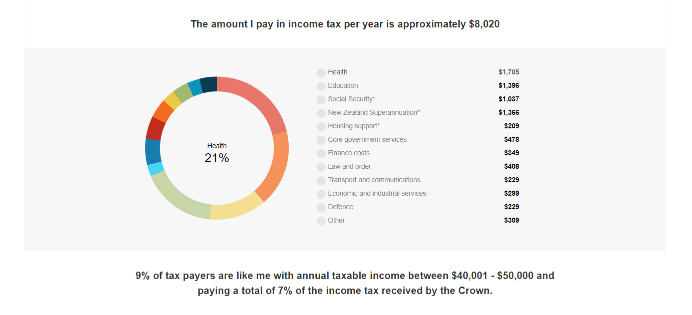
Budget 2018 lock-up briefing by:
Jono Bredin
Director and Head of Tax
PKF Bredin McCormack Rewcastle Ltd
jono@pkfbmr.nz
DDI: (03) 951 3162
Views are my own

